- Write Java code to define List . Insert 5 floating point numbers in List, and using an iterator, find the sum of the numbers in List.

package collections;
import java.util.ArrayList;
import java.util.Iterator;
import java.util.List;
public class q1 {
public static void main(String[] args) {
float sum=0.0f;
List<Float> li=new ArrayList<Float>();
li.add(1.1f);
li.add(2.1f);
li.add(3.3f);
li.add(4.4f);
li.add(6.6f);
Iterator<Float> iterator=li.iterator();
while (iterator.hasNext())
{
sum=sum + iterator.next();
}
System.out.println(sum);
}
}

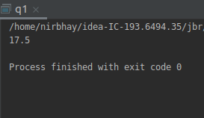

- Write a method that takes a string and returns the number of unique characters in the string.

package collections;
import java.util.HashSet;
public class q2 {
static int count(String s)
{
HashSet<Character> obj=new HashSet<>();
char s1[]=s.toCharArray();
for (int i=0;i<s1.length;i++)
{
obj.add(s1[i]);
}
return obj.size();
}
public static void main(String[] args) {
String s="nirbhay khurana";
System.out.println(count(s));
}
}

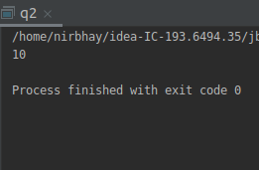

- Write a method that takes a string and print the number of occurrence of each character in the string.

package collections;
import java.util.HashMap;
public class q3 {
static void characterCount(String str)
{
HashMap<Character, Integer> hashMap = new HashMap<>();
char charArray[] = str.toCharArray();
for (char eachCharacter : charArray)
{
if(hashMap.containsKey(eachCharacter))
{
hashMap.put(eachCharacter, hashMap.get(eachCharacter)+1);
}
else
{
hashMap.put(eachCharacter, 1);
}
}
for (HashMap.Entry entry: hashMap.entrySet())
{
System.out.println(entry.getKey()+" = "+entry.getValue());
}
}
public static void main(String[] args) {
String s = "nirbhay khurana";
characterCount(s);
}
}
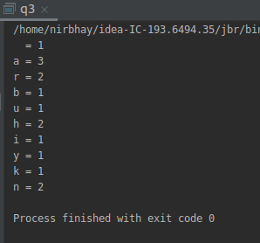

- Write a program to sort HashMap by value.

package collections;
import java.util.*;
public class q4 {
public static HashMap<String,Integer> sortByValue(HashMap<String,Integer> obj)
{
List<Map.Entry<String,Integer>> li= new LinkedList<>(obj.entrySet());
Collections.sort(li, new Comparator<Map.Entry<String, Integer> >() {
public int compare(Map.Entry<String, Integer> o1,
Map.Entry<String, Integer> o2)
{
return (o1.getValue()).compareTo(o2.getValue());
}
});
HashMap<String, Integer> temp = new LinkedHashMap<>();
for (Map.Entry<String, Integer> aa : li) {
temp.put(aa.getKey(), aa.getValue());
}
return temp;
}
public static void main(String[] args) {
HashMap<String, Integer> obj1 = new HashMap<>();
obj1.put("A", 28);
obj1.put("B", 67);
obj1.put("C", 34);
obj1.put("D", 11);
obj1.put("E", 73);
Map<String, Integer> obj2 = sortByValue(obj1);
for (Map.Entry<String, Integer> en : obj2.entrySet()) {
System.out.println("Key = " + en.getKey() +
", Value = " + en.getValue());
}
}
}

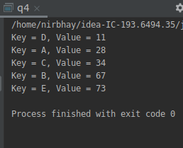

- Write a program to sort Employee objects based on highest salary using Comparator. Employee class{ Double Age; Double Salary; String Name

package collections;
import java.util.ArrayList;
import java.util.Collections;
import java.util.Comparator;
class emp{
double age;
double salary;
String name;
public emp(double age, double salary, String name )
{
this.age=age;
this.salary=salary;
this.name=name;
}
public String toString()
{
return this.name + " " + this.age + " " + this.salary;
}
}
class sortbysal implements Comparator<emp>
{
public int compare(emp a, emp b)
{
return (int) (a.salary - b.salary);
}
}
public class q5 {
public static void main(String[] args) {
ArrayList<emp> li=new ArrayList<>();
li.add(new emp(30,21000,"A"));
li.add(new emp(32,17000,"B"));
li.add(new emp(28,22000,"C"));
li.add(new emp(35,25000,"D"));
li.add(new emp(29,19000,"E"));
System.out.println("unsorted");
for (int i=0; i<li.size(); i++)
System.out.println(li.get(i));
Collections.sort(li,new sortbysal());
System.out.println("sort by salary");
for (int i=0; i<li.size(); i++)
System.out.println(li.get(i));
}
}

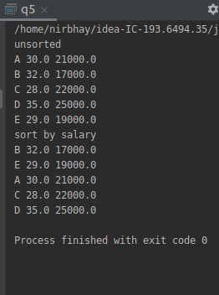

- Write a program to sort the Student objects based on Score , if the score are same then sort on First Name . Class Student{ String Name; Double Score; Double Age

package collections;
import java.util.ArrayList;
import java.util.Collections;
import java.util.Comparator;
class student{
String name;
double score;
double age;
public student(String name, double score, double age)
{
this.name=name;
this.score=score;
this.age=age;
}
public String toString()
{
return this.name + " " + this.score + " " + this.age;
}
public double get_score()
{
return score;
}
public String get_name()
{
return name;
}
}
class sort_student implements Comparator<student>
{
public int compare(student s1, student s2)
{
int score_com= (int) (s1.get_score()-s2.get_score());
int name_com= s1.get_name().compareTo(s2.get_name());
if (score_com==0)
return ((name_com==0) ? score_com : name_com);
else
return score_com;
}
}
public class q6 {
public static void main(String[] args) {
ArrayList<student> li=new ArrayList<>();
li.add(new student("A",7,25));
li.add(new student("B",9,28));
li.add(new student("C",5,29));
li.add(new student("D",7,24));
li.add(new student("E",4,24));
li.add(new student("F",1,21));
li.add(new student("G",5,20));
System.out.println("unsorted");
for (student obj : li)
System.out.println(obj);
Collections.sort(li,new sort_student());
System.out.println("sorted");
for (student obj : li)
System.out.println(obj);
}
}

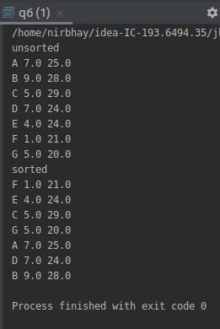

- Print the elements of an array in the decreasing frequency if 2 numbers have same frequency then print the one which came first.

package collections;
import java.util.*;
public class q7 {
public static HashMap<Integer,Integer> sort(HashMap<Integer,Integer> obj)
{
List<Map.Entry<Integer,Integer>> li= new LinkedList<>(obj.entrySet());
Collections.sort(li, new Comparator<Map.Entry<Integer, Integer> >() {
public int compare(Map.Entry<Integer, Integer> o1,
Map.Entry<Integer, Integer> o2)
{
return o2.getValue() - o1.getValue();
}
});
HashMap<Integer, Integer> temp = new LinkedHashMap<>();
for (Map.Entry<Integer, Integer> aa : li) {
temp.put(aa.getKey(), aa.getValue());
}
return temp;
}
public static void main(String[] args) {
List<Integer> integerList = new ArrayList<>();
List<Integer> integerList2 = new ArrayList<>();
integerList.add(2);
integerList.add(12);
integerList.add(7);
integerList.add(2);
integerList.add(12);
integerList.add(5);
integerList.add(7);
integerList.add(7);
System.out.println("Elements in an array");
System.out.println(integerList);
Iterator<Integer> it=integerList.iterator();
for (int i=0;i<integerList.size();i++)
{
integerList2.add(Collections.frequency(integerList,it.next()));
}
HashMap<Integer,Integer> map1=new LinkedHashMap<>();
for (int i=0;i<integerList.size();i++)
{
map1.put(integerList.get(i), integerList2.get(i));
}
System.out.println("Elements of an array in the decreasing frequency:");
Map<Integer, Integer> obj2 = sort((HashMap<Integer, Integer>) map1);
for (Map.Entry<Integer, Integer> en : obj2.entrySet()) {
System.out.println(en.getKey());
}
}
}

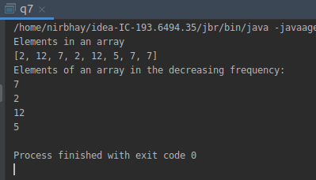

- Design a Data Structure SpecialStack that supports all the stack operations like push(), pop(), isEmpty(), isFull() and an additional operation getMin() which should return minimum element from the SpecialStack. (Expected complexity - O(1))

package collections;
import java.util.Stack;
class SpecialStack extends Stack<Integer>
{
Stack<Integer> min = new Stack<>();
void push(int x)
{
if(isEmpty())
{
super.push(x);
min.push(x);
}
else
{
super.push(x);
int y = min.pop();
min.push(y);
if(x < y)
min.push(x);
else
min.push(y);
}
}
public Integer pop()
{
int x = super.pop();
min.pop();
return x;
}
int getMin()
{
int x = min.pop();
min.push(x);
return x;
}
public static void main(String[] args)
{
SpecialStack s = new SpecialStack();
s.push(15);
s.push(6);
s.push(7);
s.push(9);
s.push(21);
s.push(34);
System.out.println(s);
System.out.println(s.getMin());
}
}

